Multi-Variable Linear Regression: Feature Scaling & Learning Rate
1-Page Summary Report | Combined Coursera C1-W2 Labs (NumPy Vectorization + Multi-Var LR + Scaling)

Problem Statement
Housing-price prediction with multiple features (size in sqft, bedrooms, floors, age) fails or converges extremely slowly when gradient descent is run on the raw data. Feature magnitudes differ by orders of magnitude, so a single learning rate either overshoots (cost rises) or crawls. Practitioners need a reliable way to (1) diagnose the failure, (2) rescale features, and (3) obtain stable, fast convergence and correct out-of-sample predictions.

Solution Strategy
• Implement vectorized predict / cost / gradient using NumPy (np.dot / matrix products) for speed and clarity.
• Systematically test three regimes of α on unscaled data to surface divergence vs. slow progress.
• Apply z-score normalization (store μ, σ from the training set) so every feature has mean 0 and unit variance.
• Re-run gradient descent with a much larger, stable α (≈ 0.1); verify with cost curves and prediction-vs-target plots.
• For any new house, apply the identical transform before calling the model.
• Provide alternates (min-max, fully vectorized gradient, sklearn StandardScaler) and a parameterised simulation.

Solution
On synthetic but realistic housing data (n = 100), raw-feature runs with α ≥ 9.9e-7 diverge; smaller α decreases cost only slowly. After z-score scaling the same algorithm with α = 0.1 reaches a low cost in a few hundred iterations. Predictions align closely with targets; a held-out example (1200 sqft, 3 bed, 1 floor, 40 yr) produces a coherent dollar estimate. Min-max scaling yields comparable final cost. Fully vectorized gradients match the loop version to machine precision.
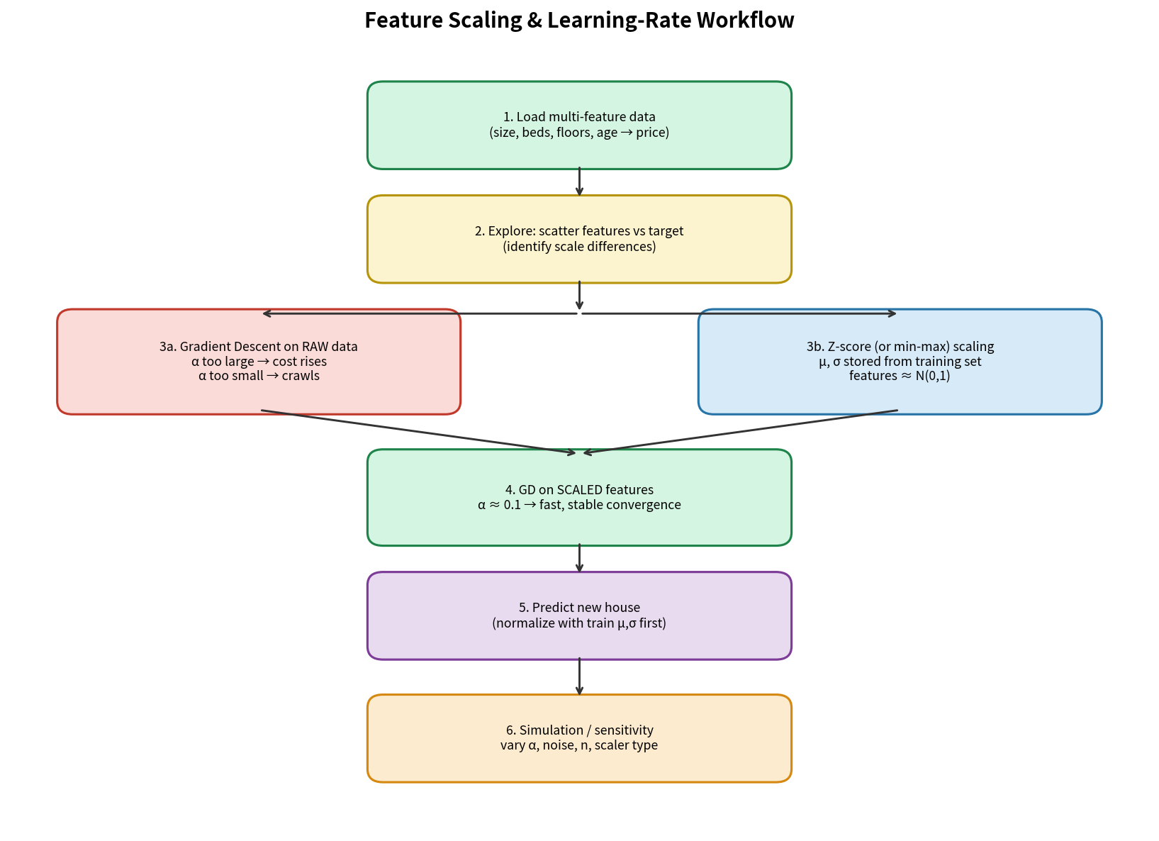

Key Takeaways
• Unequal feature scales make a shared learning rate unstable; z-score (or min-max) equalizes gradient magnitudes.
• After scaling, α ≈ 0.1 is a robust default for batch gradient descent on standardized tabular data.
• Always persist training μ and σ; every future example must be transformed with the same statistics.
• Cost-versus-iteration plots are the fastest diagnostic for α and scaling problems.
• Audience adaptation: technicians need equations and contour intuition; executives need the quantified speed-up and a concrete house-price example.
Audience note (from supplied PDFs): data-literate readers receive the full math and contour discussion; decision makers receive the headline “scaling turns a divergent/slow optimizer into a production-ready pricing tool in < 1 000 iterations.”

